**Practical - 3**

Lab Scenario:

Assume, for JK Enterprises organization two server instances have been configured in IBM Security Identity Manager (ISIM) using IBM Security Directory Server (SDS) Organization wants to improve performance, availability and reliability. So it has decided to make copies/replicas of the server instance and check the replicated instance.

**Distributed Directories :**

A distributed directory is useful to organizations with offices in several locations, because each office can maintain its own directory, and yet to a client it appears as just one directory.

It is also useful for large directories because you improve scalability and performance when you share the data across different servers.

**Replication Directories :**

In a replicated directory, information that is stored in one part of the directory is also stored elsewhere as one or more copies.

Replication involves copying data and ensuring that the copies are synchronized.

1) Create Replication Credentials on IDSLDAP1

a) Open Firefox. Click on the Web Admin Tool SDS bookmark on the bookmark toolbar.

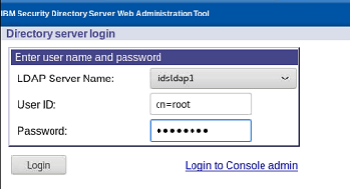

Login to LDAPServer idsldap1 using cn=root/P@ssw0rd.

b) Select Replication Management on the left panel. Click Manage Topology.

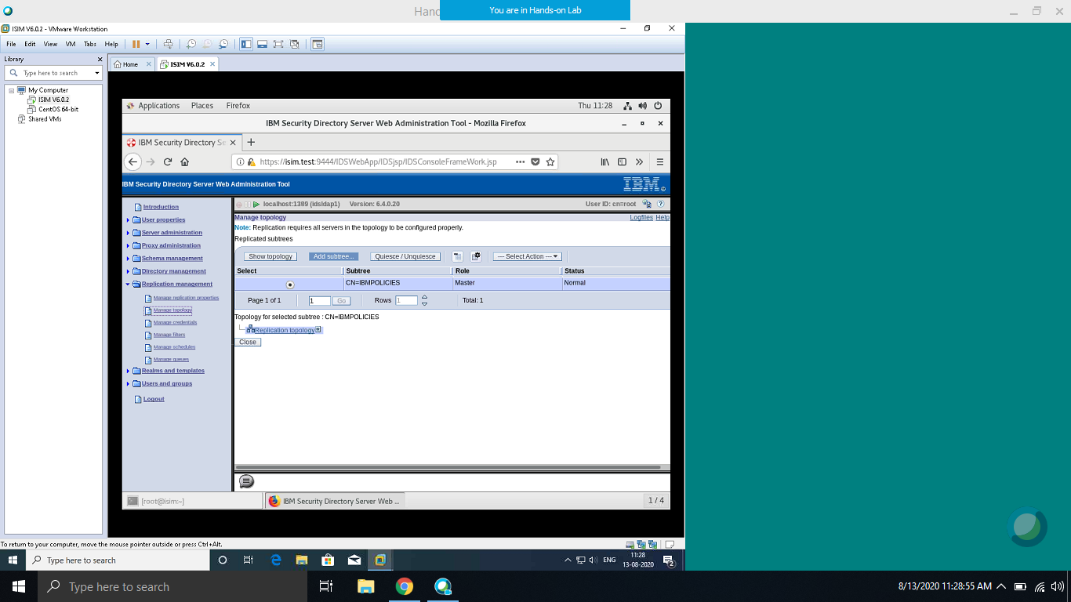

c) Click the Add subtree button



d) Select o=jke in the Subtree DN box from Browse.

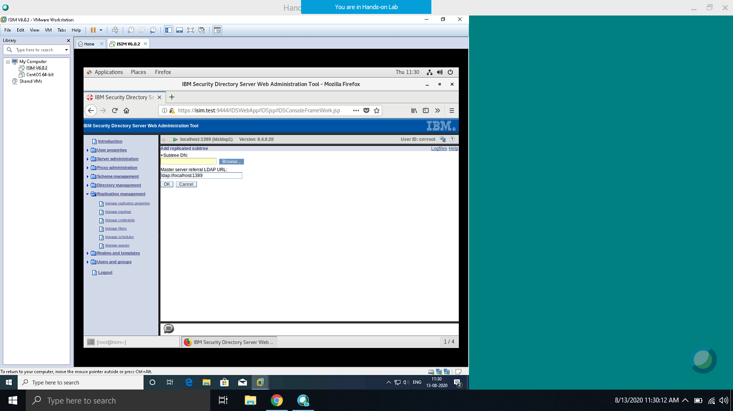

Check ldap://localhost:1389 is in the Master server referral URL box

Click the OK button

e) In Replication Management, click Manage credentials.

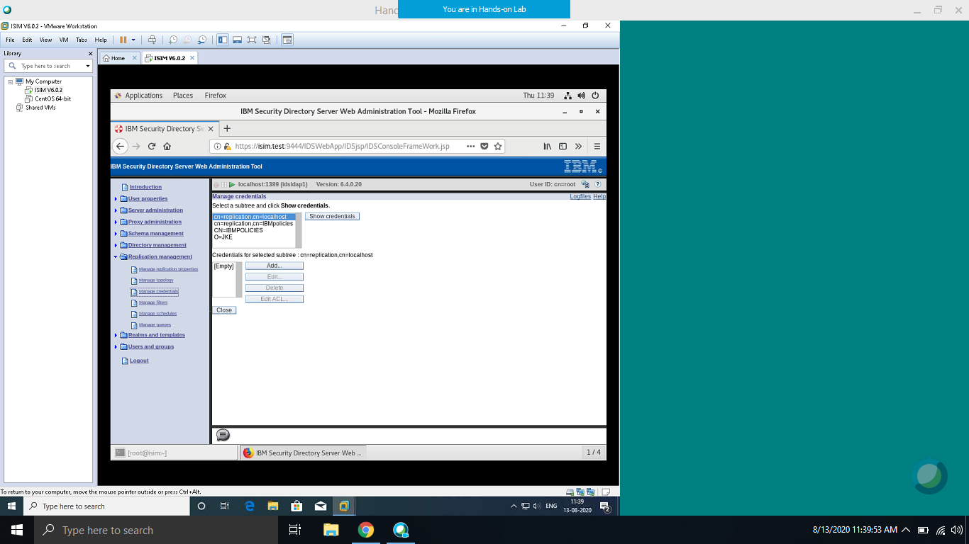

f) Select O=JKE from the subtree list. Click the Show Credentials button (no credentials for the O=JKE tree)

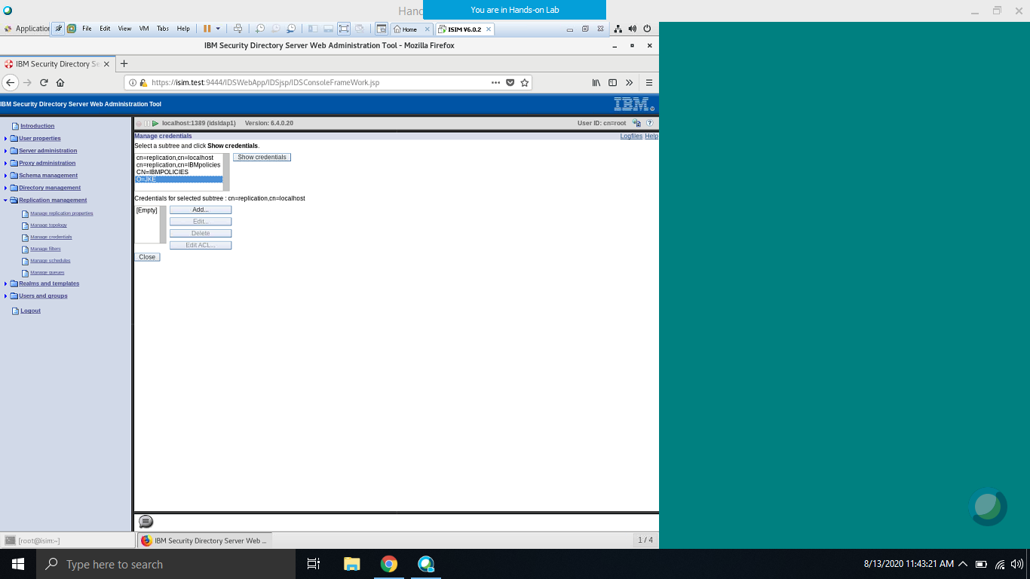

g) Click the Add button - to add the credentials for the replicated subtree

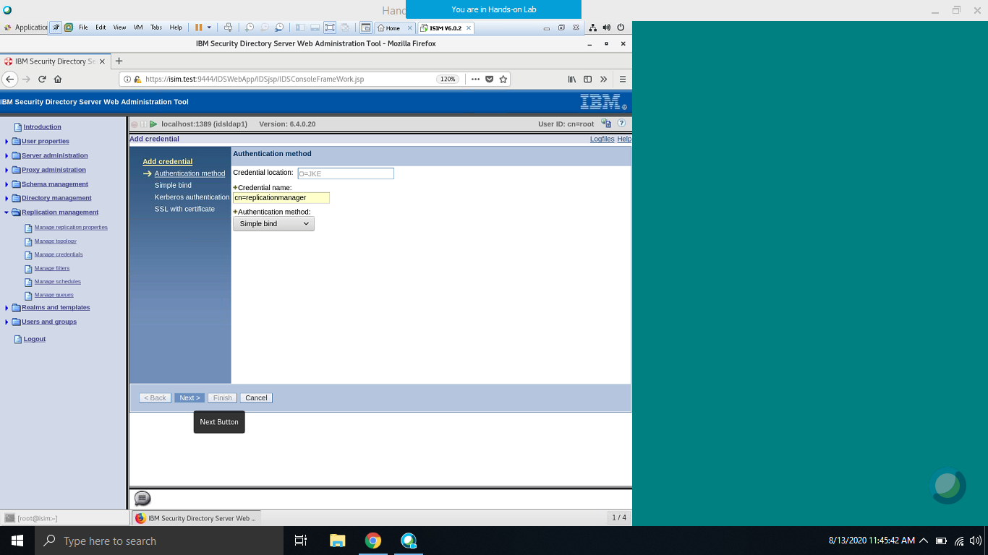

- Credential Name: cn=replicamanager

- Authentication method: Simple bind

Click the Next button

h) Enter the Simple Bind information

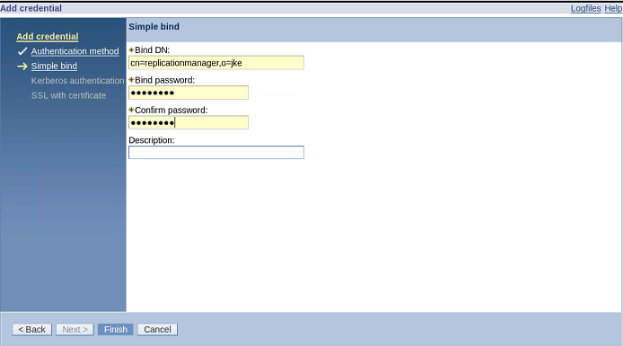

- Bind DN – cn=replicamanager,o=jke

- Bind password – P@ssw0rd

- Confirm password – P@ssw0rd

- Description – leave blank

Click the Finish

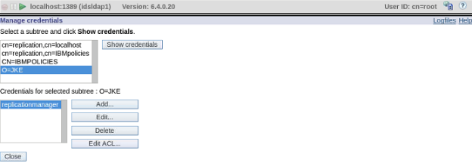

Credential is successfully added to the JKE subtree

Click the Close.

2) Define Replica Server in IDSLDAP1

a) Replication management select Manage topology.

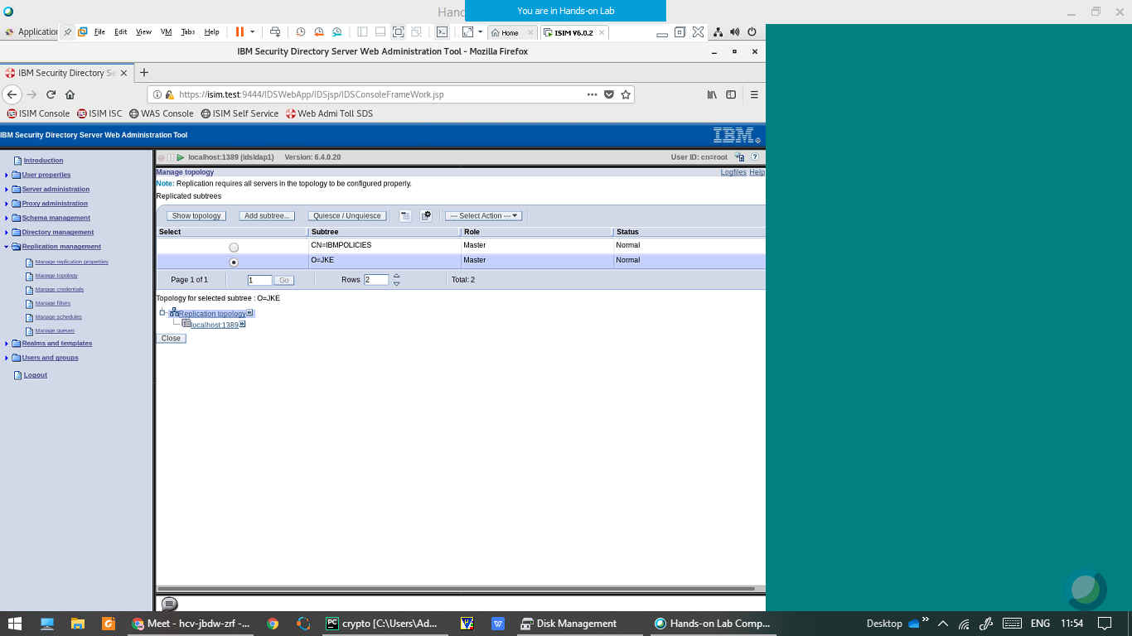

Select O=JKE subtree, click Show topology.

Click on localhost:1389

b) Click Add master 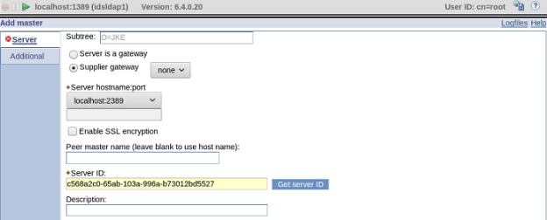

Server Hostname:port: localhost:2389

Enable SSL: unchecked

Peer Master: blank

Server ID: click the Get server ID button (ID for server localhost:2389)

Description : leave blank

c)Credential Object – click the Select button



d) Select the radio button next to the O=JKE entry

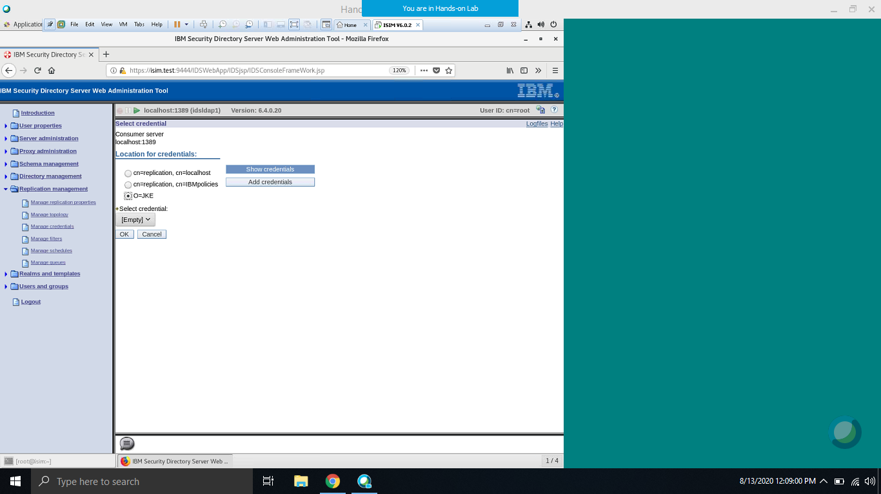

Click the Show Credentials button

e) Click the Additional menu tab

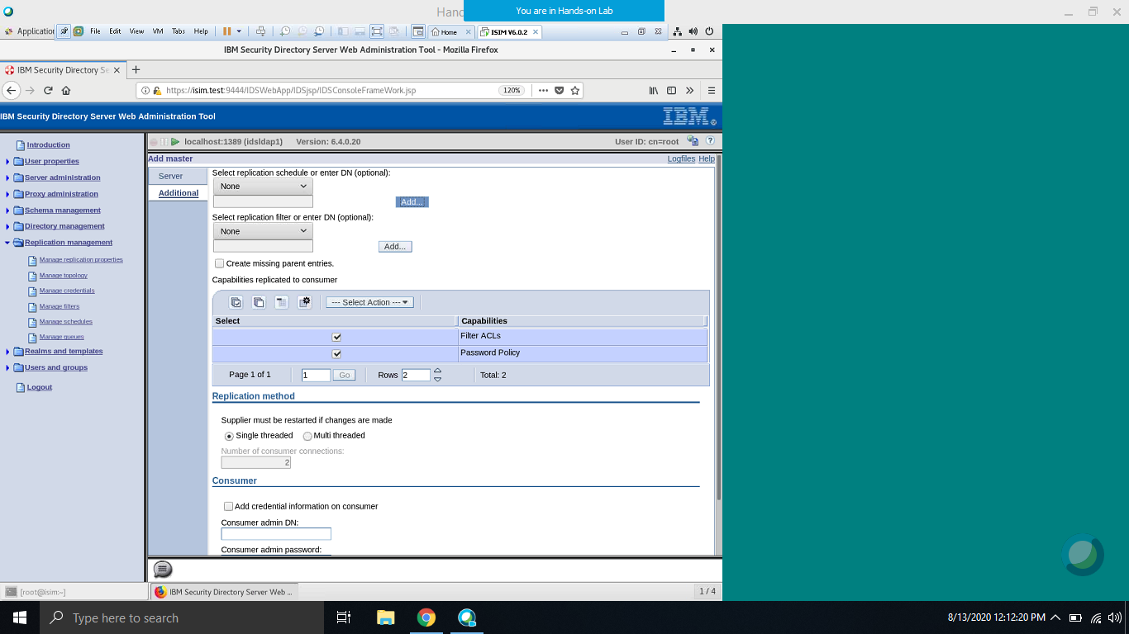

f) The Add Replica –On this screen, we add the credentials to the consumer machine. Select the checkbox next to “Add credential information on consumer”

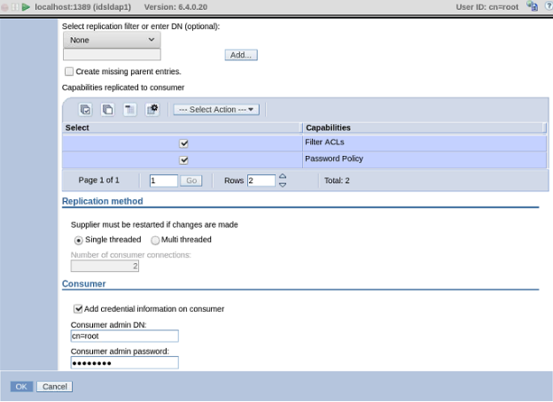

- Consumer admin DN – cn=root

- Consumer admin password – P@ssw0rd

Click the OK

g) Select O=JKE radio button and press Show Credentials

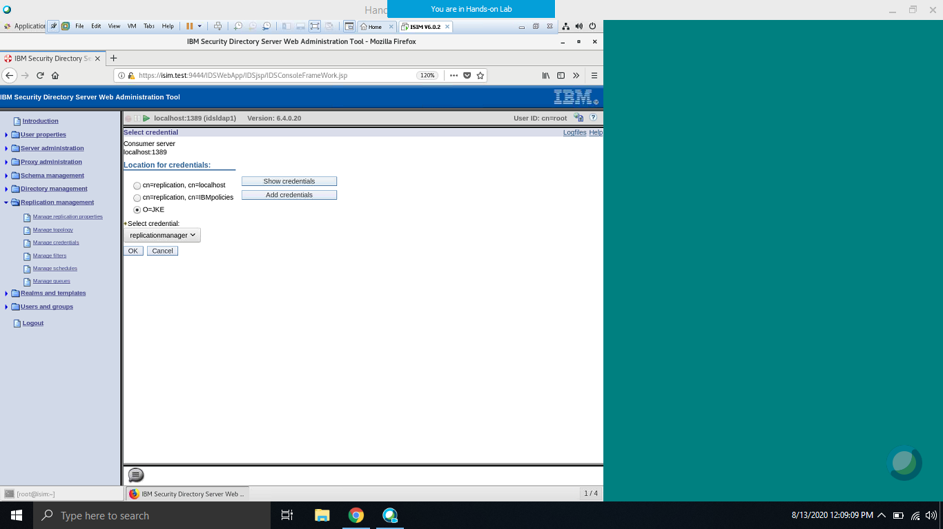

h) Select the checkbox next to “Add credential information on consumer”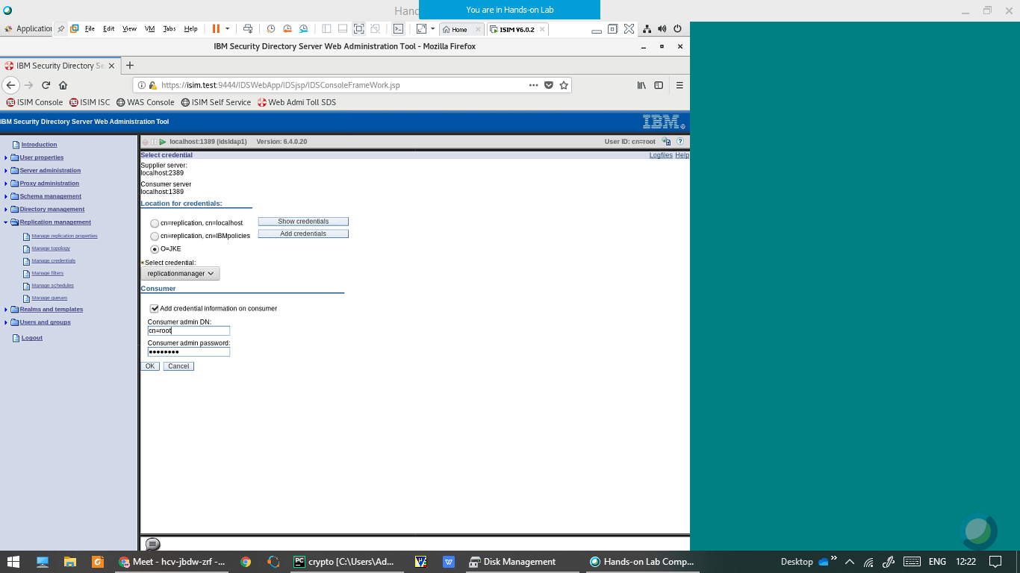

- Consumer admin DN – cn=root

- Consumer admin password – P@ssw0rd

Click the OK

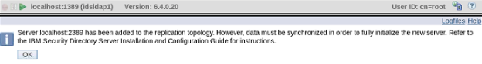

i) In Replication Management go to Manage Queues. The queue is in suspended state, select the Radio button and Click Suspend/Resume.

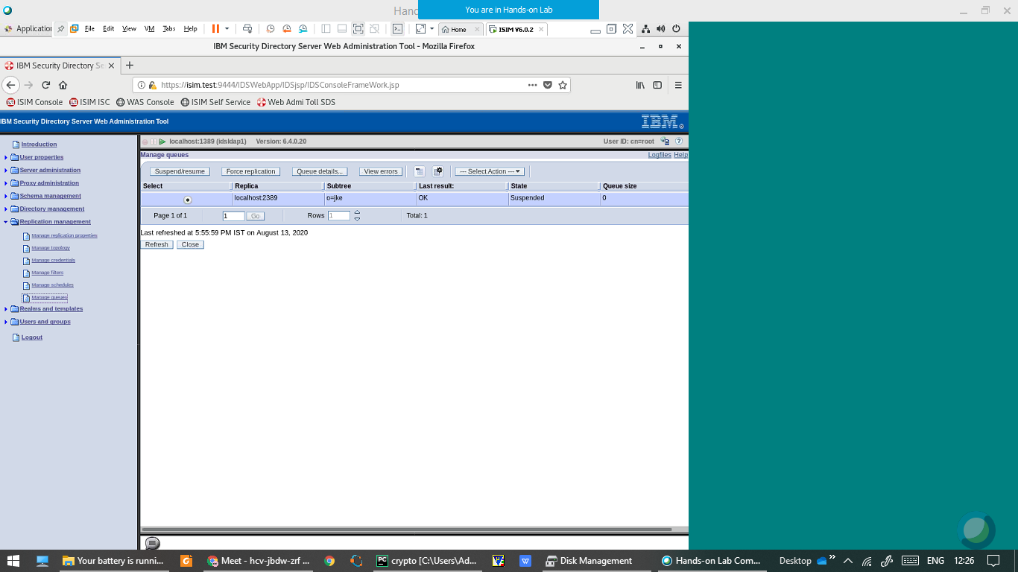

j) Click Refresh. The queue will be in Ready state.

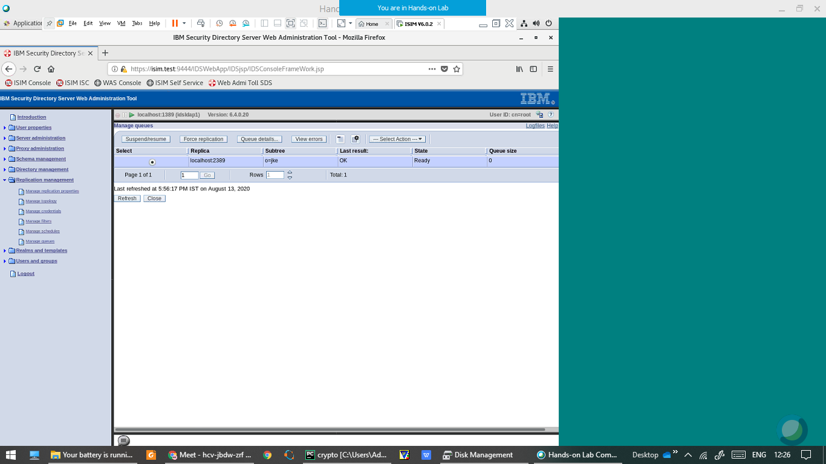

The replication is now started from IDSLDAP1 to IDSLDAP2

Click Logout from the left pane.

k) Start the queue on IDSLDAP2 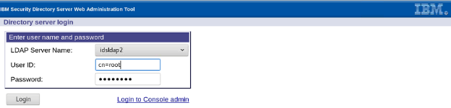

Login to idsldap2 in Web Admin Tool using the user cn=root/P@ssw0rd

l) In Replication Management go to Manage Queues. The queue is in suspended state, select the Radio button and Click Suspend/Resume.



m) Click Refresh. The queue will be in Ready state



The replication is now started from IDSLDAP2 to IDSLDAP1

Click Logout from the left pane.

3) Verifying Replication

a) Open the SDS Web Administration Tool, Login to idsldap1 server and Click Directory management in the left pane.

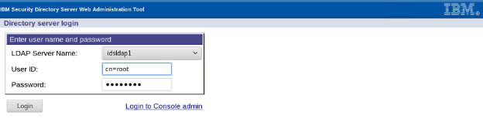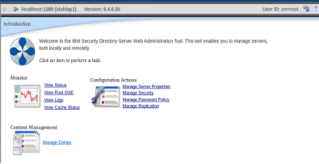

b) Select Manage entries. Select the radio button next to the o=jke branch. Click the Expand button.

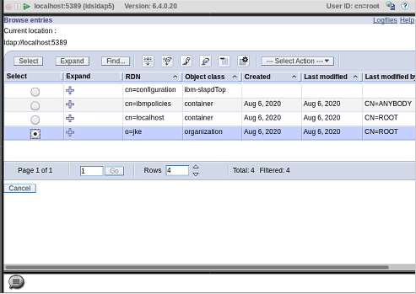

c) Select user cn=joe from the list, and click the Edit attributes button

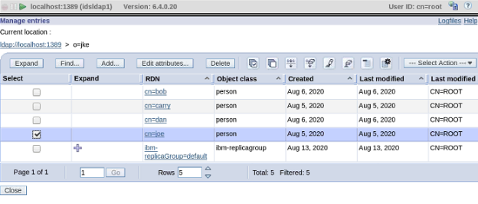

d) Modify the sn attribute to some new value, say “walter” to “Hayden”.Click Next and then Finish.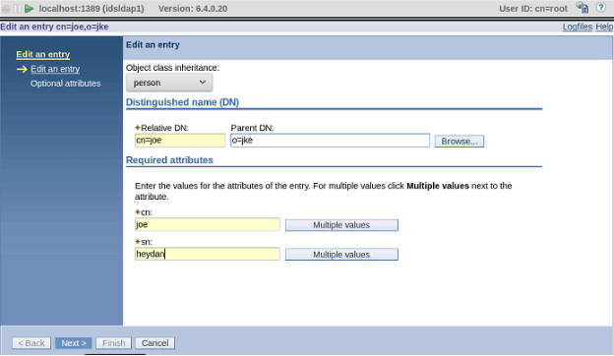

Logout from left pane

e) Login using idsldap2 

f) Select Manage entries. Select the radio button next to the o=jke branch. Click the Expand button.



g) Select user cn=joe from the list, and click the Edit attributes button



h) Now you can see sn as Hayden which we changed on IDSLDAP1. The changes get replicated.

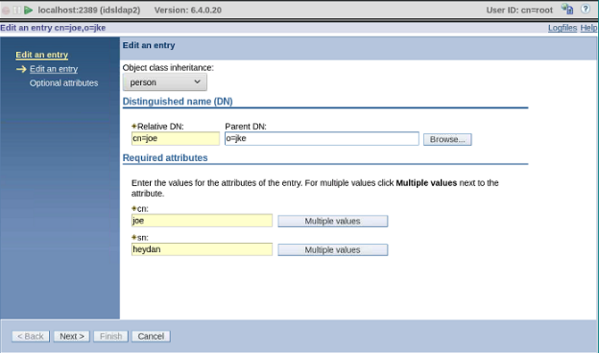

Press Cancel and Logout from left pane